Operating Modes of Chalcogenide Switching Devices Exhibiting Cognitive Behavior

Author(s)
Boil Pashmakov and Guy Wicker
Ovonic Cognitive Computing, LLC, 27000 Pebblestone St., Southfield, MI 48034 USA
bpashmakov@ovshinskyinnovation.com, wicker@ovshinskyinnovation.com

ABSTRACT
Operational regimes for Ovonic Threshold and Memory Switches (OTS and OMS) are discussed, which demonstrate how these devices can be used to implement artificial neurons in large-scale neural networks. In particular, the 'accumulation' mode of operation of an OMS device is shown to imitate a brain neuron's plasticity in its capacity to accumulate pulses (energy) from multiple inputs until reaching a percolation threshold or 'firing'. It is further argued that the 'normal' (direct-overwrite) mode of programming OMS devices to different resistance values can be used to weight artificial neuron inputs. A new type of proprietary ovonic device - the 3-terminal Ovonic Threshold Switch (3TOTS) is also discussed and shown to be useful in neural network implementation schemes. Other uses of those operating modes are discussed, such as using OMS to encrypt data and to perform arithmetic operations and factoring, and the use of 3t-OTS as access devices in place of transistors.
Key words: Ovonic, neural network, encryption, 3TOTS
1. INTRODUCTION
The OTS and OMS are now a commercially viable memory technology [1]. However, work at ECD
has shown that these devices can be used to implement cognitive behavior and control [2]. Thus, a
rich range of additional characteristics and operation regimes of these devices can be exploited to
exhibit comparable behavior to that of Neurons [3,4,5]
2. EXPERIMENTS
The OMS is well known for multi-bit storage of binary or analog information, but alternative, subthreshold (in terms of pulse width) pulsing can be used to make these devices work as threshold
detectors with a binary storage output as shown in Fig 1. Thus an OMS device can be used in a pulse
(energy) accumulation mode until reaching a threshold and 'firing', or changing state. This mode of
device operation was called 'cognitive mode' by Stan Ovshinsky since it closely emulates the
behavior of a brain neuron. Further, the possibility to program the resistance of an OMS device can be
used to weight the synapses in a neural network. Another device developed at ECD was the 3-
terminal OTS which allowed for the control of the value of the threshold voltage. Figure 2 shows data
collected on a 3-terminal OTS device, where the threshold level is selectable.
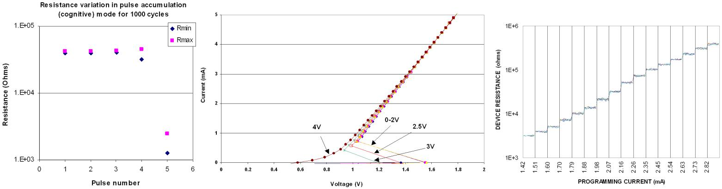Fig. 1 Fig. 2 Fig. 3
3. RESULTS & DISCUSSION
Synaptic weighting in a neural network can be adjusted using the multi-state regime of the OMS
(Fig. 3). Synaptic switching can be performed in 2 ways; the percolation (accumulation) regime of
the OUM or a weighted threshold of the 3-terminal OTS. The additional complexity this adds to a
neural network can be transparent to conventional network training algorithms; so evolutionary
algorithms modifying synaptic weights can occur in much the same fashion as conventional neural
model training. One big difference is that iterations can occur on a microsecond time-frame.
Variations in device behavior serve to inhibit local optima from converging. Alternatively, we are
exploring the use of the percolation regime to open the possibility of iterative network feedback, more
closely emulating the behavior of the brain. We have also demonstrated how the percolation regime
can be used to perform such complex operations as division or fast factoring of large numbers which is important in modern encryption algorithms.

4. CONCLUSION
Different modes of operation in OMS and OTS were developed at ECD more than a decade
ago. At the time there were no commercially available OMS and OTS devices to try and
implement those new regimes in real-life large neural networks. Now that is possible for the
first time. By learning to exploit these operating modes, we hope, that large neural networks
will be implemented and new and improved learning algorithms will be developed with faster
convergence and much faster operation.
REFERENCES
1 Intel Optane announcement, 3/19/2017 https://newsroom.intel.com/news/intel-introduces-worlds-most-responsive-data-center-solid-state-drive/

2. S.R. Ovshinsky, B. Pashmakov, D. Strand, T. Ohta, “Novel Storage Mechanisms Using Ovonic Phase Change Materials”, 2004 Asia-Pacific Data Storage Conference (APDSC’04), Taoyuan, Taiwan (September 27-30, 2004)

3. S.R.Ovshinsky, “The Ovonic Cognitive Computer”, E*PCOS (2004)

4. S.R. Ovshinsky and B. Pashmakov: “Multi-terminal device having logic functional,”
US Patent 7,186,998 B2, Mar.6, 2007.

5. S.R.Ovshinsky, “New Transformative Possibilities for Ovonic Devices”, E*PCOS (2011)
Biographies

Boil Pashmakov and Guy Wicker began working for Ovonic Cognitive Computing, LLC in 2003. They have secured the IP rights to over 330 chalcogenide switching patents and are continuing their development of cognitive systems using chalcogenide devices.

